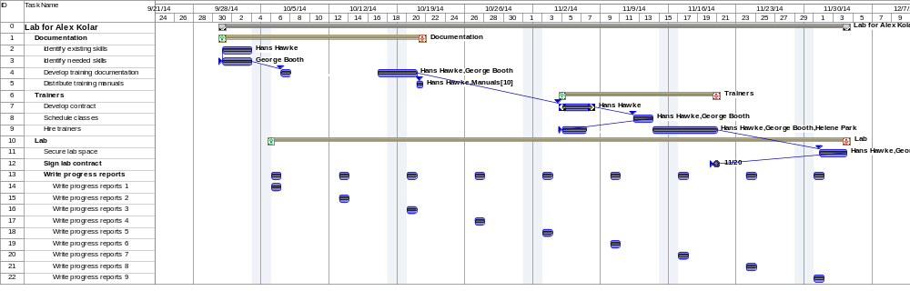

This Gantt chart represents actual progress on a finished project.
Alex Kolar

